3 JANVIER 2024

INFORMATION & COMMUNICATION TECHNOLOGIES

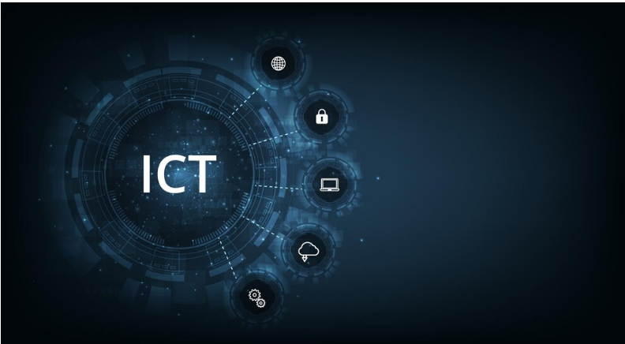

*Done by****:***

* ATTIGUI FATIMA ZOHRA
* KEMLI AMIRA
* MANSOUR MANEL
* MESSABIS SARAH NESRINE
* CHAMMA MALAK

**SECTION : B**

**GROUPE : 37**

|  |  |
| --- | --- |
|  |  |
| 1 | Introduction |
| 2 | Technologies included in ict |
| 3 | Components of ict |
| 4 | Services and tools that are integral to ICT |
| 5 | The importance of ict in business |
| 6 | Challenges ict creates |
| 7 | ICT, the digital age and digital divide |
| 8 | Technological Advancement of ICT |
| 9 | conclusion |

* **Information and communications technology:**
* ICT, or information and communications technology (or technologies), is the infrastructure and components that enable modern computing. Among the goals of IC technologies, tools and systems is to improve the way humans create, process and share data or information with each other. Another is to help them improve their abilities in numerous areas, including business; education; medicine; real-world problem-solving; and even leisure activities related to sports, music, and movies.
* There is no single, universal definition of ICT because the technologies, devices and even ideas related to ICT are constantly evolving. However, the term is generally accepted to mean all devices, networking components and applications. When combined, these help people and organizations interact in the digital world.
* **What technologies are included in ICT?**

ICT encompasses the internet-enabled sphere and the mobile one powered by wireless networks. It includes antiquated technologies, such as [landline](https://www.techtarget.com/whatis/definition/landline)  telephones, radio and television broadcast -- all of which remain widely used alongside today's cutting-edge ICT pieces, such as artificial intelligence and robotics.

The internet, [internet of things](https://www.techtarget.com/iotagenda/definition/Internet-of-Things-IoT), metaverse, virtual reality and [social media](https://www.techtarget.com/whatis/definition/social-media) are also part of ICT, as are [cloud computing](https://www.techtarget.com/searchcloudcomputing/definition/cloud-computing) services, [video conferencing](https://www.techtarget.com/searchunifiedcommunications/definition/video-conference) and collaboration tools, [unified communications](https://www.techtarget.com/searchunifiedcommunications/definition/unified-communications) systems and mobile communication networks. Emerging, work-in-progress or still-nascent technologies like [5G](https://www.techtarget.com/searchnetworking/definition/5G)/[6G](https://www.techtarget.com/searchnetworking/definition/6G), [Web3](https://www.techtarget.com/whatis/definition/Web-30), and [quantum computing](https://www.techtarget.com/whatis/definition/quantum-computing) are also in the ICT universe.

Any technology, infrastructure, component, or device that enables communications, data sharing, and global connectivity between humans and between humans and machines is included in the umbrella term *ICT*.

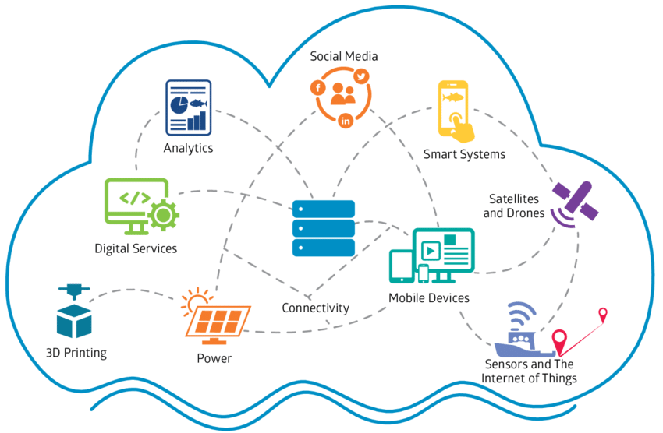

## What are the components of ICT?

The list of ICT components is exhaustive and continues to grow. Some components, such as computers and telephones, have existed for decades. Others, such as smartphones, digital TVs and robots, are more recent entries.

ICT components include the following:

* Devices (hardware).
* Software.
* Middleware.
* Data.
* Wired networks.
* Wireless networks.
* Communication technologies.
* The cloud.
* Communications protocols and interfaces.
* Information security and governance policies.

ICT means more than its list of components. It encompasses the application of all those various components. It's here that the real potential, power and danger of ICT emerges -- for economic, societal, and interpersonal transactions and interactions.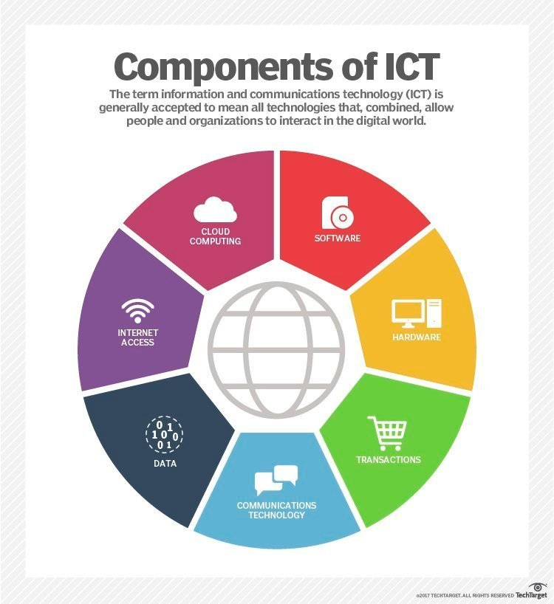

* **Services and tools that are integral to ICT:**

**1. Google Services:** Google, a global technology giant, offers a diverse range of services that have become integral to individuals and businesses worldwide. 

* **Google Search:** The world's most widely used search engine, facilitating access to vast amounts of information.
* **Gmail:** A popular email service with advanced features, including collaboration tools and extensive storage.
* **Google Drive:** Cloud storage and collaboration platform, enabling users to store and share documents, photos, and other files.
* **Google Workspace:** A suite of productivity tools, including Google Docs, Sheets, and Slides, fostering collaborative work environments.
* **Google Maps:** Provides mapping and navigation services, with features like real-time traffic updates and location-based services.
* **Android OS:** The dominant operating system for mobile devices, powering a significant portion of smartphones and tablets globally.

**2. Microsoft:** Microsoft, another technology giant, has a strong presence in the ICT sector, offering a wide array of products and services.

* **Microsoft Office 365:** A suite of productivity tools, including Word, Excel, PowerPoint, and Teams, enhancing collaboration and communication.
* **Azure Cloud Services:** Microsoft's cloud computing platform, offering services like virtual computing, storage, and AI capabilities.
* **Windows OS:** Widely used operating system for personal computers, powering a majority of desktops and laptops globally.
* **Microsoft Edge:** Web browser with advanced features and integration with Microsoft services.
* **Skype and Microsoft Teams:** Communication platforms for video conferencing, messaging, and collaboration.
* **Xbox:** Microsoft's gaming platform, illustrating the company's diversification into entertainment technologies.

**Emerging trends:** The ICT landscape is dynamic, with ongoing developments and trends shaping the industry. Some notable trends include the rise of artificial intelligence, 5G technology, and increased emphasis on cyber security to address evolving threats.

* **Why ICT is important for businesses:**

For businesses, advances within ICT have brought a slew of cost savings, opportunities and conveniences. They include the following:

* Highly automated businesses processes that have cut costs.
* The [big data](https://www.techtarget.com/searchdatamanagement/definition/big-data) revolution, where organizations are turning the vast trove of data generated by ICT into insights that drive new products and services.
* ICT-enabled transactions such as internet shopping and telemedicine and social media that give customers more choices in how they shop, communicate and interact.
* **Challenges ICT creates:**

Its many benefits notwithstanding, ICT has also created problems and challenges for organizations, individuals and society. The digitization of data, the expanding use of the high-speed internet and the growing global network together have created new opportunities for crime. Increasingly, [bad actors](https://www.techtarget.com/whatis/definition/threat-actor) leverage these opportunities to hatch new schemes to gain unauthorized access to enterprise or government systems. They do so to steal money, intellectual property or private information. Many [cybercrimes](https://www.techtarget.com/searchsecurity/definition/cybercrime) are also aimed at disrupting systems that control critical infrastructure and, ultimately, creating widespread chaos and panic.

Developments in ICT have also brought new [automation](https://www.techtarget.com/searchcio/definition/labor-automation) technologies and robots that sometimes displace workers, especially workers involved in repetitive, low-value tasks. In some cases, ICT has let more people limit their face-to-face interactions with others, creating or exacerbating social issues such as [trolling](https://www.techtarget.com/whatis/definition/trolling), cyber bullying, isolation, loneliness and depression.

## ICT, the digital age and digital divide:

ICT has changed drastically how people work, communicate, learn and live. It continues to revolutionize all parts of the human experience as first computers and now robots do many tasks humans once handled.

ICT's importance to economic development and business growth has been so monumental that it's often credited with ushering in the Fourth Industrial Revolution. ICT also underpins broad shifts in society, as individuals en masse are moving from personal, face-to-face interactions to ones in the digital space. This new era is frequently termed the  digital age

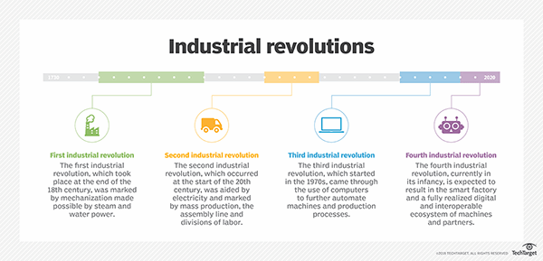

**Technological Advancement of ICT :**

|  |  |
| --- | --- |
| **year** | **Technological advancement** |
| 1837 | Morse code and telegraph |
| 1876 | telephone |
| 1895 | Wireless telegraphy |
| 1927 | television |
| 1947 | transistor |
| 1951 | UNIVAC 1 “first commercial computer“ |
| 1969 | ARPANET “foundation of the internet” |
| 1971 | First email |
| 1990 | World wide web |
| 1991 | GSM “global system for mobile communication “ |
| 1994 | Netscape navigator |
| 1998 | google |
| 2001 | Commercial 3G networks |
| 2004 | Facebook |
| 2007 | iphone |
| 2008 | Bitcoin “first blockchain-based cryptocurrency “ |
| 2010 | 4G networks |
| 2020 | 5G networks |
| 2023 | Zoom “350million daily meeting attendees” |

* **Conclusion:**

In summary, ICT is an integral part of the modern world, influencing how information is created, shared, and accessed. Its impact extends across various sectors, contributing to economic development, innovation, and improved communication on a global scale.

Thank you